Hello.
You have reached out to us to earn our digitizing business. We are a full scale embroidery company specializing in luxury goods with remarkable thread content. At the moment, we do in fact have an RFP in the market seeking a partner who can help us understand the following:

We have been contacted by a Cashmere company to sew their products. The criteria is as follows:
- Clean Backing
- Finished Back
- Back stitches to not be white but the color of the garment/robe/blanket for a more professional and clean look

Here are two examples of what our client has done in the past:
Back:
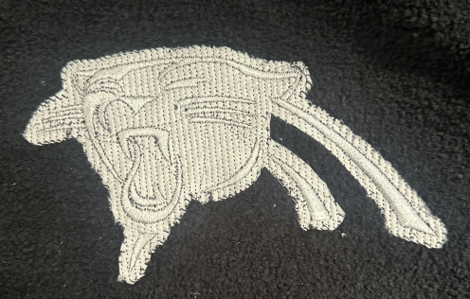
Front:
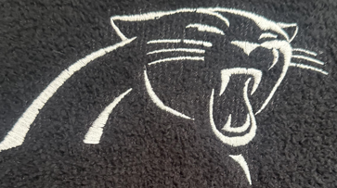

Back:
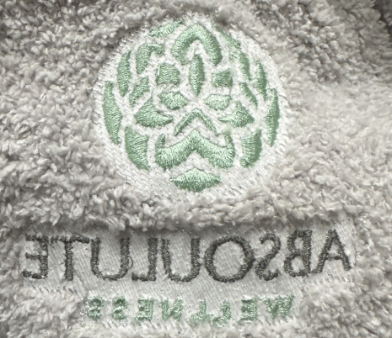
Front:
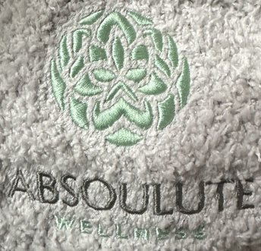

The client has also expressed the following:
We're also starting to do knockdown stitches in the same color ground as the items so the back won't be white whenever possible.

We are trying to accomplish the following:
- What does a digitized file need to encompass to create the finished back look of the embroidery?
- What type of backing if at all would we need to use?
- What needle would work to get the smallest crispest letters?
So, we want to try to use the PURELL logo for this process and to incorporate the request above from our client to utilize the finished back so the PURELL logo will be perfect on the cashmere robes.
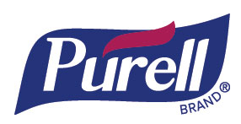
The logo needs to be no wider from Left to Right then 3”.
The word BRAND needs to be clean and sew crisp.
The R needs to sew the best it can without overpowering the word BRAND.

Please send finished logo DST, EMB, and PDF files.
Please send instructions on achieving the finished back.

